Using your Chromebook.
- Click near the timestamp in the bottom right corner, Click on the WiFi icon, and connect to your home network.
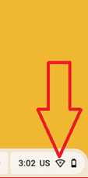
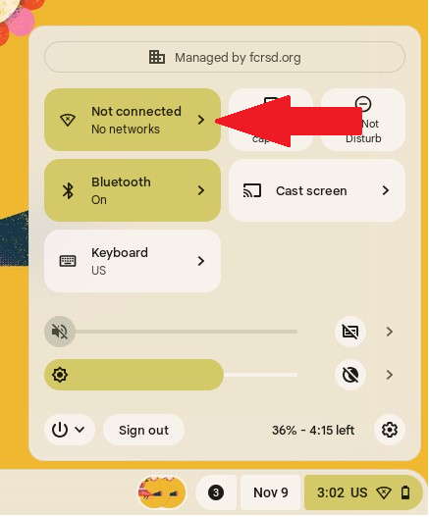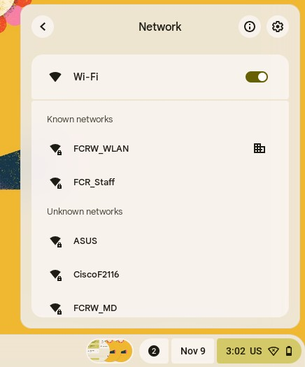

- Enter your childs email address – This will be the first 3 letters of their last name, first 3 letters of their first name + @fcrsd.org after it.
Example – Stephen Glynn – glyste@fcrsd.org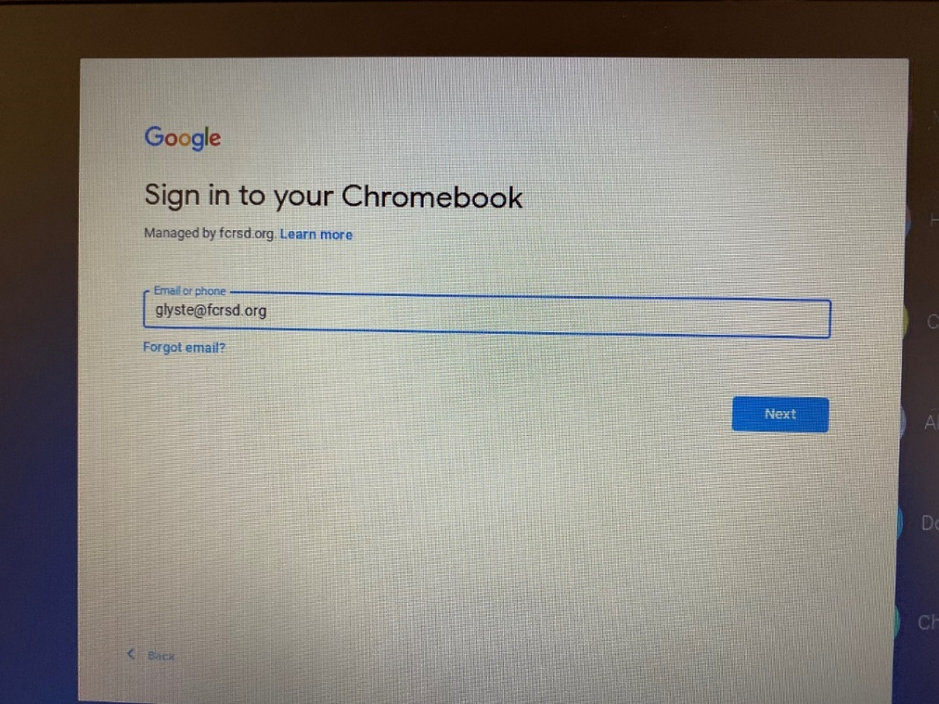

- Password will be their lunch codes.
- Next, you’ll want to access your students Email, Google Classroom, and Google Meet. Start by opening up the Chrome Web Browser:
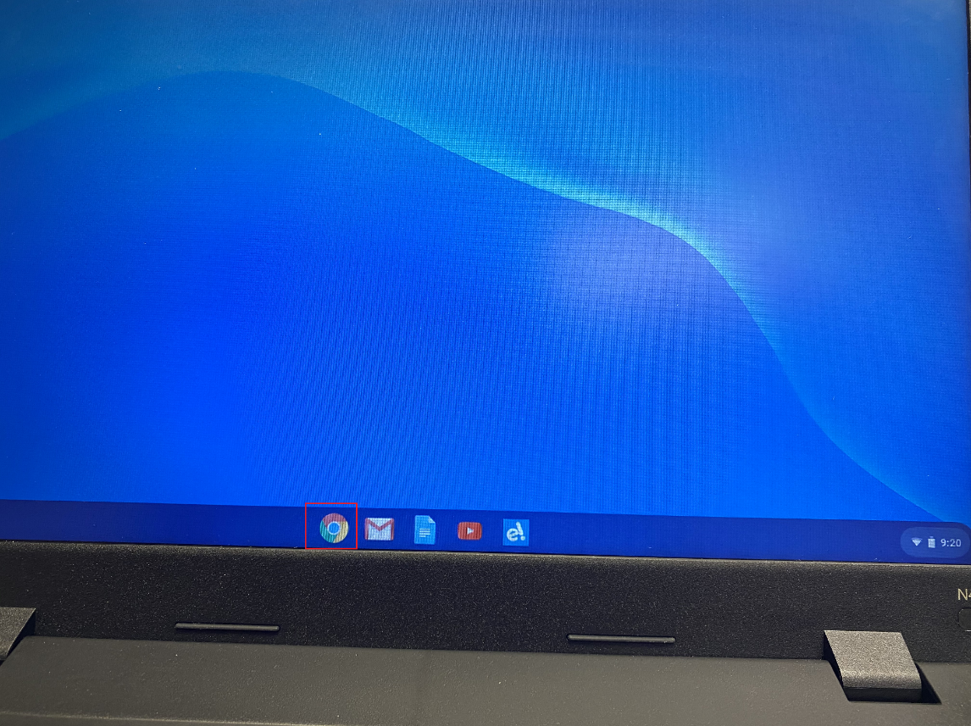

- Next click on the link for “Gmail in the upper right hand corner. You might see invitations to join a teachers Google Classroom or emails from your teacher or principal:
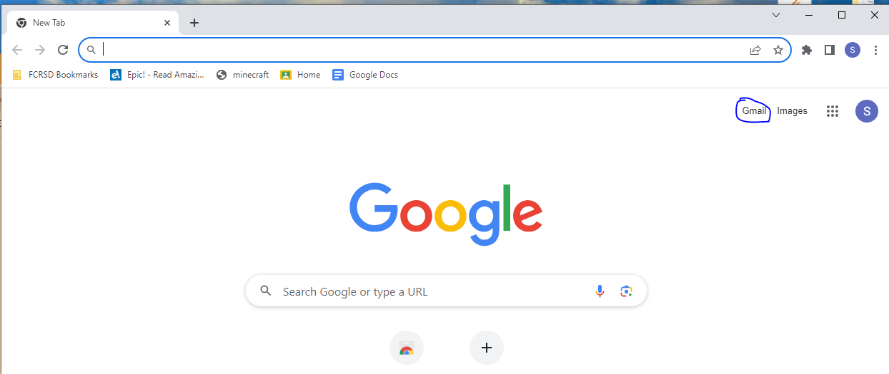

- Use the “App Switcher” button in the upper right corner, and you can find links to your student calendar, Classroom, and Google Meet. One of the most important resources is your Google Classroom. If you were invited to join by email, you can click the join button, or enter a class code if your teacher sent you a code, but students should already be connected to all classrooms.
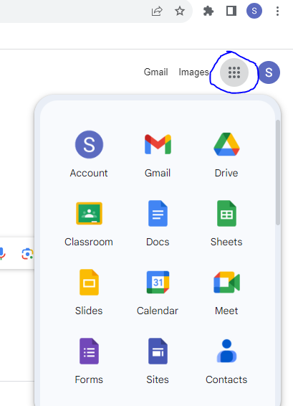
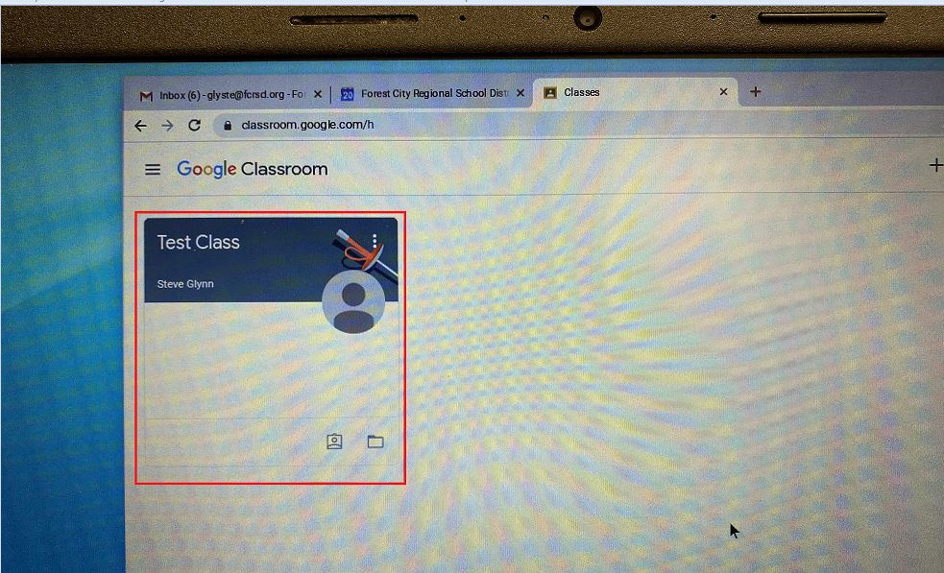
- After you click on the class, you’ll see the home screen as shown below. Announcements and assignments will be shown in the class stream, and the class Google Meet link will be on the left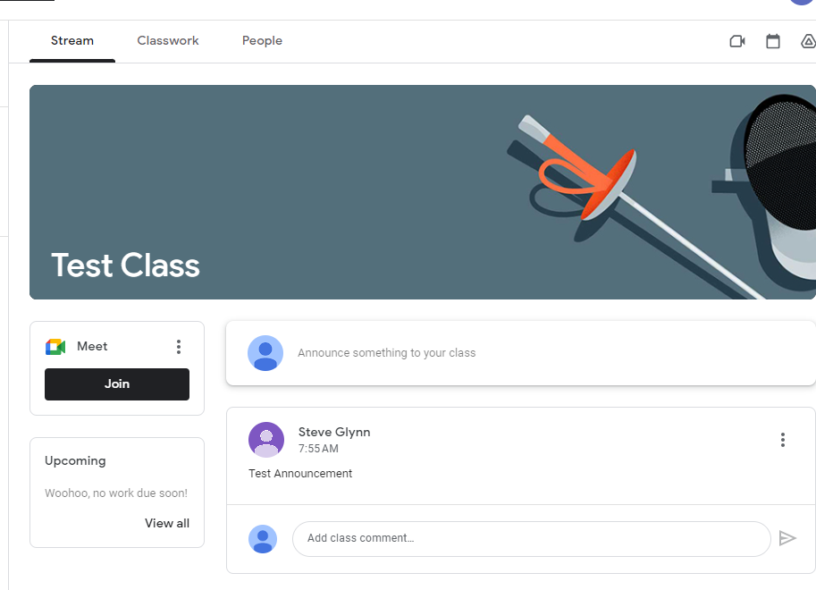

- For live instruction, you’ll click the Join link under Google Meet at the scheduled time, you’ll be taken to the Google Meeting, click the “allow” button to allow Google Meet to use your devices camera and microphone. Then click “Join Now” and you’ll be taken to the meeting.
