Using your iPad.
- The first step to using your iPad is to connect it to your Wireless Network. Find and click on the Settings icon to get started.
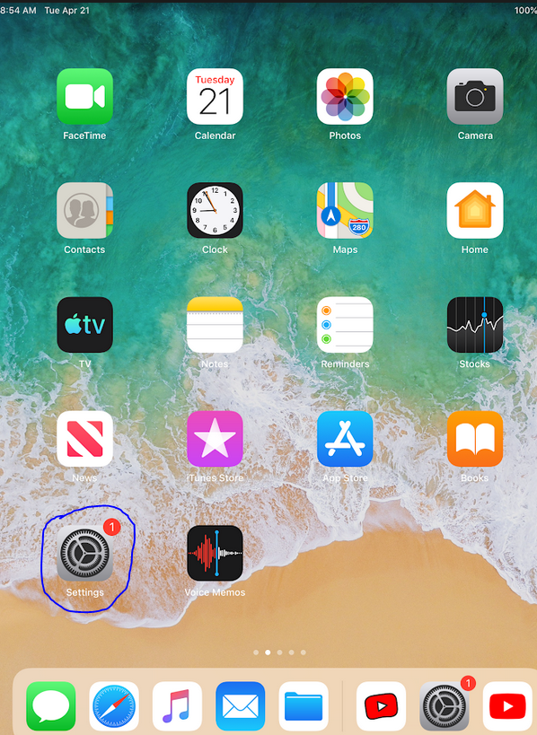
- Next, click on the WiFi options on the left hand column.
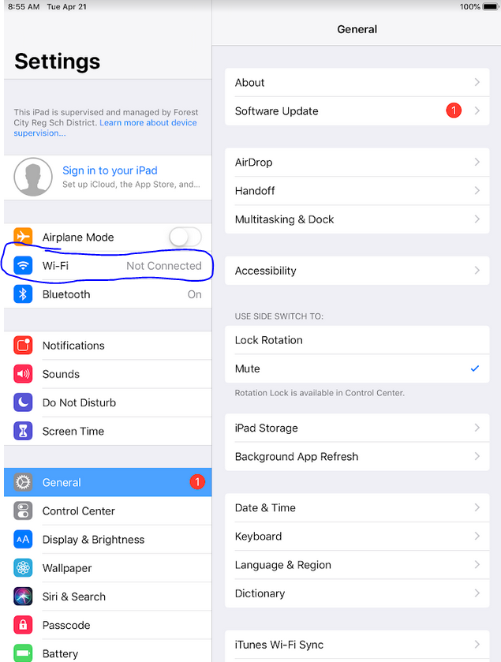
- Find your local wireless network and connect, using your password if necessary.
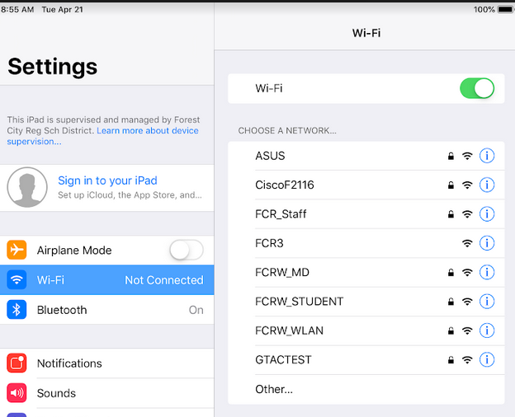
- Next, on the Home screen, you will find all the apps your student needs –Gmail, Classroom, Google Meet, and Clever. Start by opening up the “Gmail” App
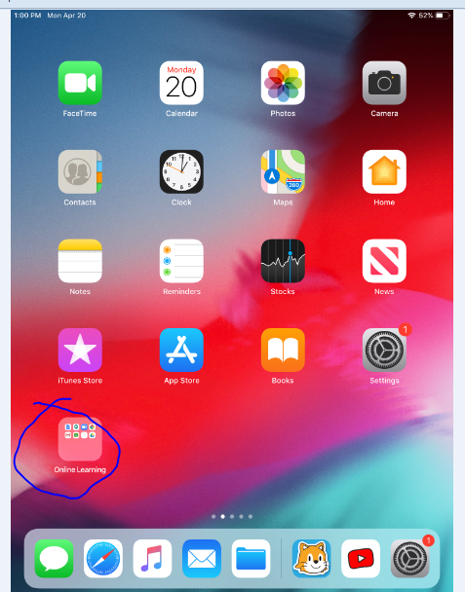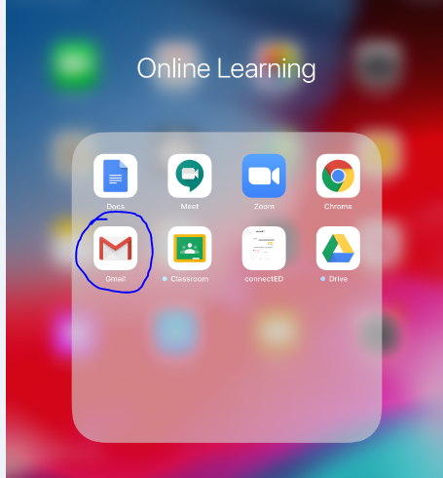

- If your student is not yet signed in (they should be) choose “Google” as the type of account, then enter your childs email address – This will be the first 3 letters of their last name, first 3 letters of their first name + @fcrsd.org after it.
Example – Stephen Glynn – glyste@fcrsd.org
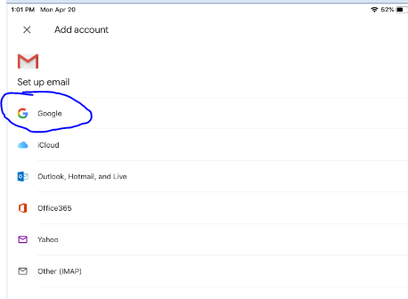

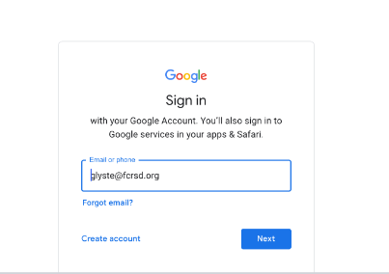

- The passwords will be the student’s lunch code.

- This will be the email your student is receiving. You might see invitations to join a teachers Google Classroom, emails from your teacher or principal, but for most students, all Google Classroom will already be set up:
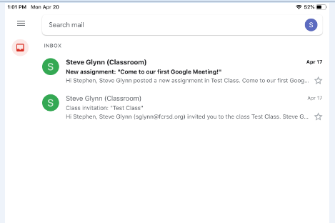

- Next, go back to the App Screen, and choose “Classroom” – You may need to sign in again with the username and password. Google Classroom will be the primary point of contact from your teacher – They’ll make announcements, give assignments, and host Google Meets from here.
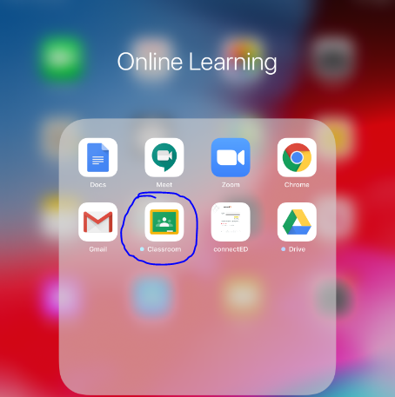
- If you already logged into one app, you might see the screen below to connect the account to another Google App, if so, just click the slider in the top right corner and it will turn blue and authorize that account. Then click “Get Started”:
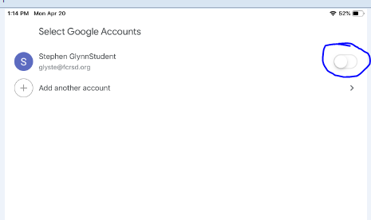
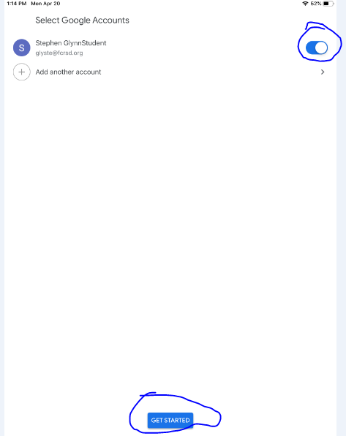

- Once logged in, any classes you’re a part of will be listed, and you can click on them to go in. In this case below, my student is a member of “Test Class”. When I click on it, I’m able to see posts and announcements created by the teacher:
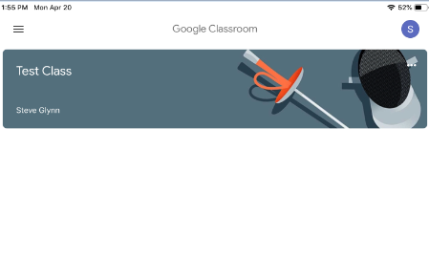
- Finally, for Google Meetings you’ll use the Meet icon in the Google Classrooms to join. Go to the class you need to meet for, and click on the camera icon in the corner:
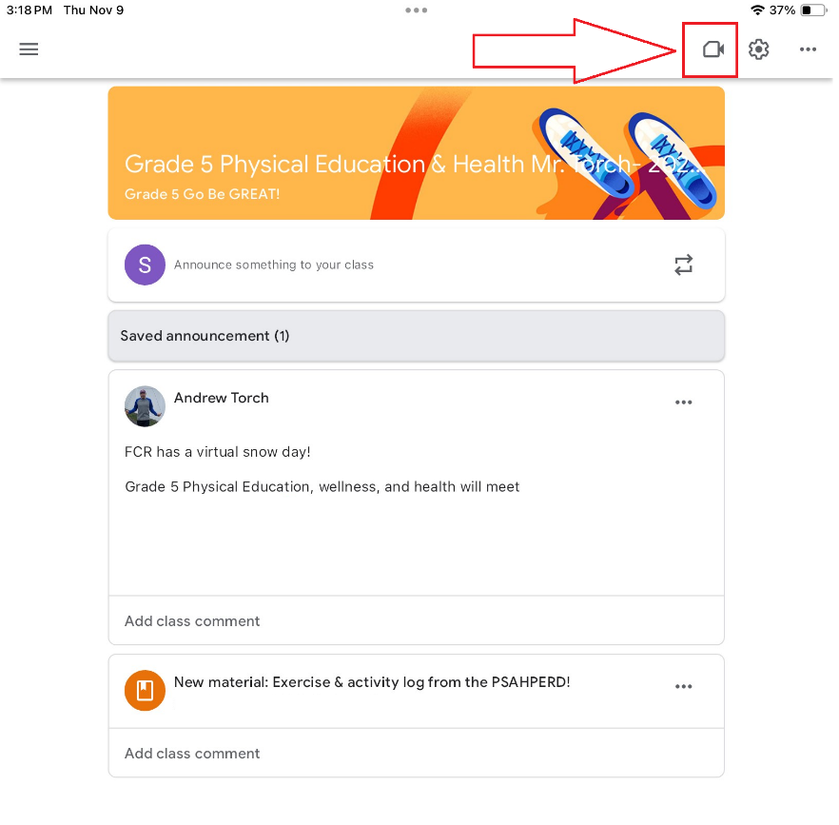

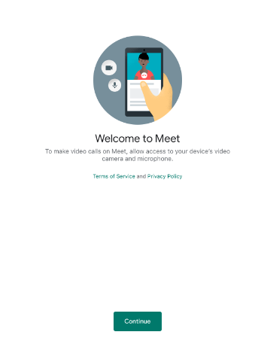
- Allow Google to connect to your devices Camera and Microphone, and click “Join Meeting” to join:
