https://www.affordableconnectivity.gov/

Click “Apply Now”

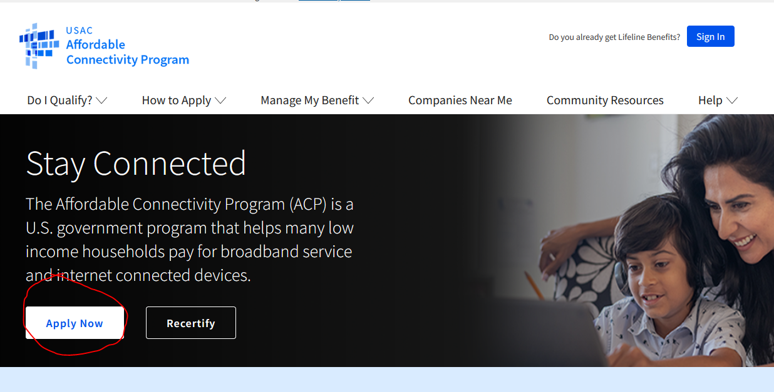

Fill out all your personal info, choose that you qualify through a child or dependent

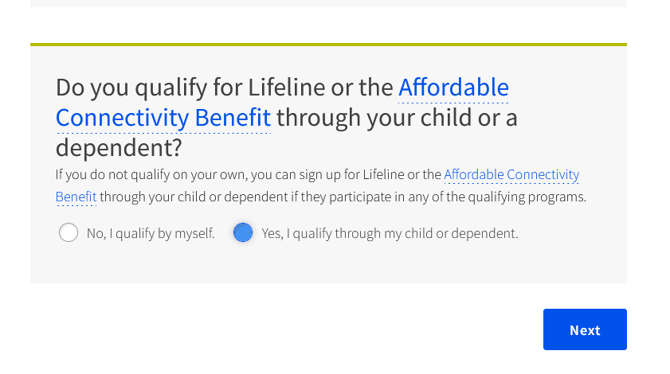
Fill out all their information, then create an account and link to email address.

Choose to start an ACP application:
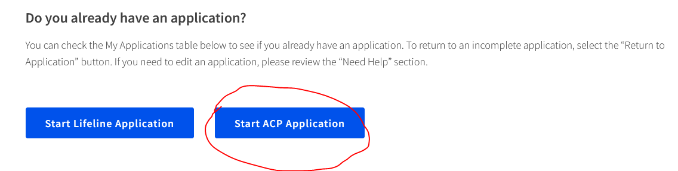
All families in FCR qualify though CEP program:
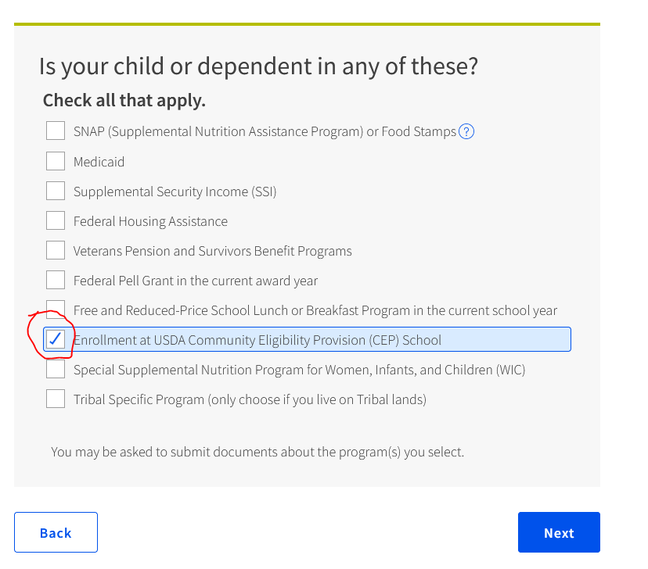
You will get a message that you could not be verified, choose the following:
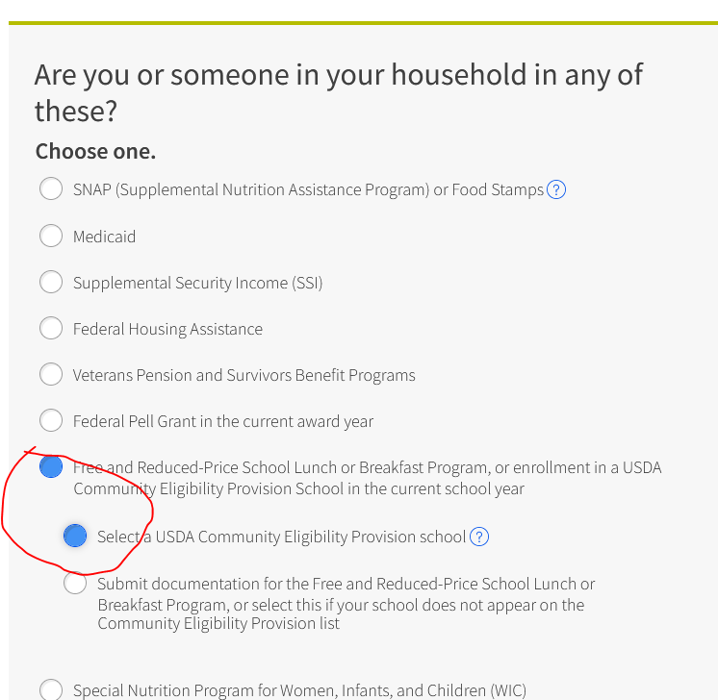
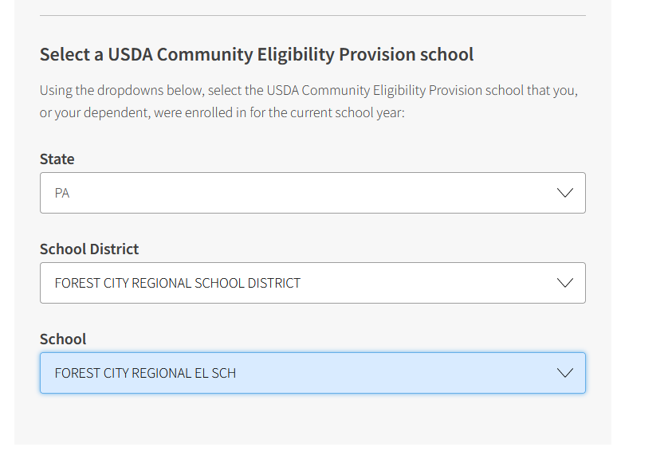
Next to confirm the student goes to the school, upload a picture or scanned PDF of your child/dependents most recent report card. You can contact the HS/ES Office, or the Technology Department (technology@fcrsd.org) if you’d like to get a copy of your report card:

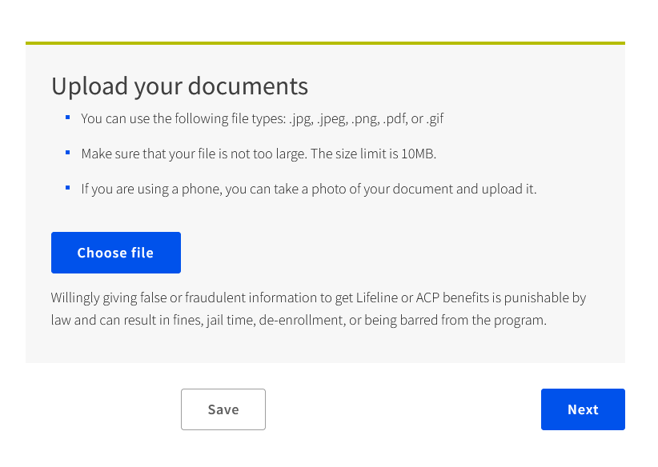
You will get an “Application Code” in your email after you get approval. You can then call NEP, Adams Cable, Xfinity or any other internet company that participates in the program to receive $30 off your monthly bill, or to sign up for a new package. All companies typically have an internet package that is fully covered by the subsidy.

